Accessibility Guide for Bank Top Lodge Self Catering Cottage - Sheen
01538 308511, https://banktoplodge.weebly.com/
Contact for accessibility enquiries: Mrs Janet Percival
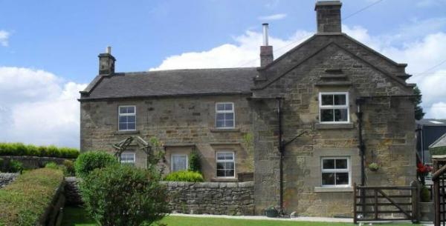

Welcome
Bank Top Lodge is a self catering cottage set on the outskirts of the village of Sheen in Derbyshire, which has been tastefully decorated and modernised to a high standard. This stone built delightful cottage has been awarded 4 star by Visit England, for its level of quality, comfort and cleanliness.
The cottage stands in open countryside with panoramic views over the Derbyshire countryside.

At a Glance

Level Access
- The main entrance has 1 step. There is no lift and no ramp.
- There is level access from the main entrance to:
- The Garden

Access with steps
- There is one step from the main entrance to the rooms on the lower ground floor, which are all on the same level. These include Lounge, Dining Room, Kitchen & the Bathroom.
Both bedrooms are situated upstairs.

Bedrooms
- We have 1 Double and 1 Twin bedroom.
- There are 12 steps, from the ground floor to the upstairs landing and bedrooms.
- We have non-allergic bedding.

Getting here
Bank Top Lodge
Sheen
Nr Buxton, Derbyshire
SK17 OHN

Travel by public transport
- Due to rural location, the best mode of transport would be by car.
- There is also an option to get by train to one of the nearest towns, which would be either Buxton or Macclesfield, and then by taxi to the property.
- The nearest train station is Buxton. The train station is 9 miles / 14.5 km from Bank Top Lodge Self Catering Cottage - Sheen.

Travel by taxi
- You can get a taxi with J.A.M Taxis by calling 01298 72333.
- You can get a taxi with Allied Taxis by calling 01298 72333.

Parking
- We have a car park. There are accessible parking spaces. The parking is less than 50 metres from the main entrance. Parking is free.
- There is a drop-off point at the main entrance.
- From the car park to the entrance, there is level access. The route is 3000mm wide, or more.
- The property is located 150 metres from a country road, though stone gateposts, tarmac driveway to the smooth flat tarmac parking area. Ample paking avaiable for at least 2/3 cars.

Arrival

Main entrance
- The door is 81mm wide.
- The main entrance has 1 step.
- The other entrance door is 81mm wide.
- Around the side of the cottage, an alternative entrance is accessible from the front garden. There are level paths to this entrance.

Getting around inside

Bedrooms
- All bedrooms have windows.
- Bedrooms have ceiling lights, wall lights, bedside lamps and natural daylight.
- Lights are energy saving and traditional filament. All bedrooms are non-smoking.
- We have non-allergic bedding.
- All bedrooms have fitted carpets.
- We have wi-fi free bedrooms, for visitors with electro-sensitivity.
- We can give details of our cleaning products on request.
- We can move the bedroom furniture, to improve accessibility.
- No bedrooms have level access. The bedroom nearest the main entrance has 12 steps.

Self catering kitchen
- We have a separate kitchen and dining room. From the main entrance to the kitchen, there is 1 step. There is no lift and no ramp.
- From the main entrance to the dining room, there is 1 step. There is no lift and no ramp.

Lounge
- From the main entrance to the lounge, there is 1 step. There is no lift and no ramp.

Getting around outside
- From the main entrance to the gardens, there is level access.
- Sheltered and private, well-kept gardens.

Guide last updated: 17 February 2020

